Adjusting Time Used for your imaging session within PPMS
At the end of your imaging session, you will need to log in to PPMS to update your actual Time Used. Otherwise, you will be charged for the full reservation time.

Option 1: At the end of your imaging session, immediately log in to PPMS and go to Book to see your current reservation. Click left on the blue box of your reservation and select the Cancel rest of the session button located at the bottom left of the screen to change the ending time of your session. The total Time Used and Price for the session will be updated.
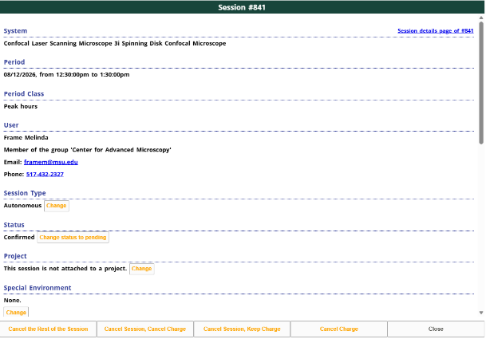

Option 2: If you do not log in to PPMS at the end of your imaging session, the next time that you log in to PPMS the following message will appear.
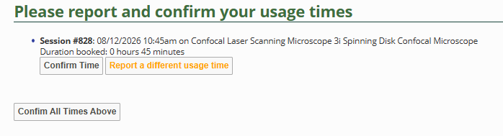
If the Duration booked is correct, then select Confirm Time. If the Duration booked is incorrect, then select Report a different usage time. Enter the total time of your imaging session in hours/minutes and then select Save & Confirm. Please note, the start and end time of your reservation will not change, but the total Time Used and Price for the session will be updated.
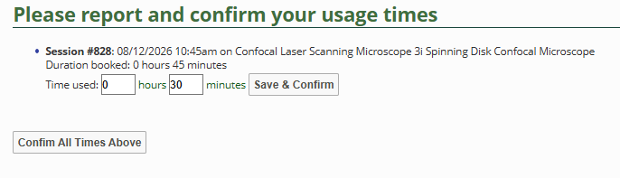

Option 3: If your reservation time has already expired and you need to edit your PPMS reservation, log in to PPMS and go to Book to find the reservation to be modified. Click left on the blue box of your reservation to see the details of the reservation.
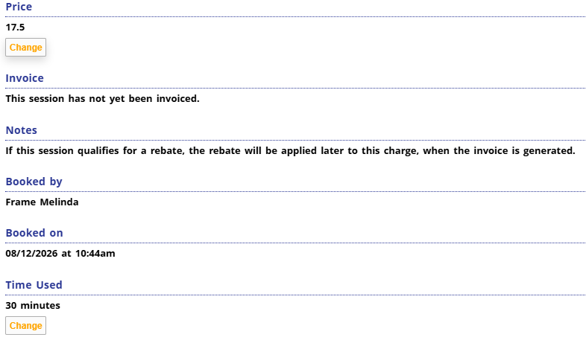
To update that total imaging time for the reservation, ignore the start and end time indicated under Period and scroll down to the bottom of the screen to the Time Used option. Click on the Change button under Time Used, enter the total imaging time of your session in minutes, and select Save.
The software will indicate that the Price of the session will be updated once the Time Used has been changed. Select Confirm to update the total Time Used for the session. If you now scroll up to the Price, the total charge for the imaging session should be correct. Note: The start and end times shown under Period will not change, but this will not affect the Time Used nor the Price for the session.
