Electron Microscopy Sciences EMS150T Sputter Coater

Creating a Profile

1. Turn the coater switch on.

2. Edit Profiles button.

3. New button.

4. Select Timed Sputter or FTM terminated sputter.

5. Tap in name field to get keyboard.

6. Type in name, i.e. Ir - 60s.

7. OK

8. In Profiles, select Profiles, i.e. Ir - 60s.

9. Edit button.

Material - Ir> OK> Use Materials Defaults> Yes

Sputter Current - 25 is good.

Sputter Time - 60> OK or Thickness if FTM terminated sputter.

Tooling Factor - 2.30 for 65 mm working distance.

Clean Target - grayed out

Pump Hold - grayed out.

10. OK.

Targets - Setting up targets

1. User> Administrator (password = admin).

2. Edit> Hardware> available targets > select 2.

3. Target pin configuration

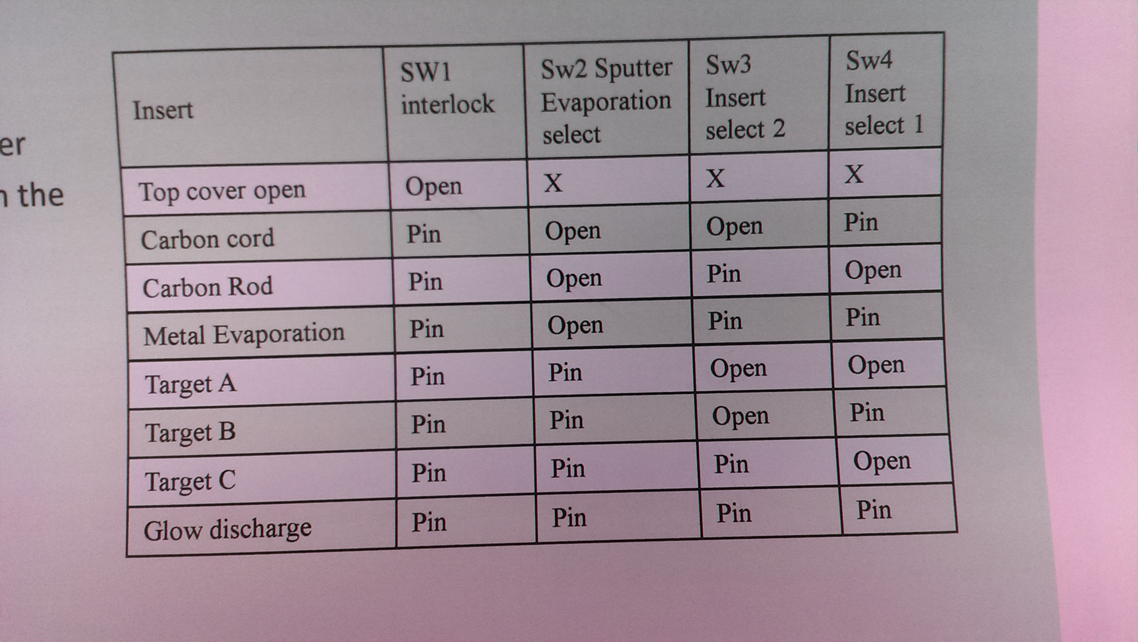

4. Log out

Targets - specifying metal for each target

1. Turn on.

2. Edit> Hardware> Target A> Pt

3. Edit> Hardware> Target B> Ir

Targets - changing

1. Turn on.

2. Edit> System> Hardware> Edit>

FTM Measurements

1. Pt 15 seconds for 2 nm: 30 sec. = 4 nm; 60 sec. = 8 nm.

2. Ir 22 seconds for 2 nm: 30 sec. = 2.7 nm; 60 sec. = 5.5 nm

Cleaning

Part 1 - Bell Jar

1. Remove the entire bell jar assembly.

2. Remove the protective cage using an allen wrench.

3. Use Amberclens and a lint free cloth, remove all deposits from the interior of the ball jar.

4. Lightly clean the outside using Amberclens.

5. Rinse in hot water, then distilled water, then let dry overnight. The reassemble.

Part 2 - Dark Space Ring and Target Holder

1. Remove the entire target.

2. Remove the dark space ring.

3. Using a new Scotch Brite, remove all metal flakes from the ring.

4. Reassemble.

Electron Microscopy Science (Quorum Technologies Ltd.) Q150T Sputter Coater

1. Administrator Password is admin, all lower case

2. Order NitrogenUltra High Purity 99.999% min, MSU 16071620

3. Order Argon Ultra High Purity 99.999% min, MSU 16051680

4. When changing targets. Edit (top menu)>System>Hardware>Edit>Change Metal.

5. FTM for Pt, 2 nm ≈15 seconds. Timed 30 s = 4 nm, 60s = 8 nm.

6. The values Al used for Pt sample coating were FTM 2 nm, sample height 65 mm, bleed vacuum 8 x 10 -3 mBar, and FTM tooling factor 2.3. All these are default. However, he used a current of 20 or 25 mA instead of 30 mA

c:\Stan\instructions\EMS150T_1.wpd