**FRET Options on Nikon A1 Confocal**

1. **Simple Ratio: Provides a simple, real-time FRET Acceptor/Donor ratio.**

***No crossover correction.***

-Select desired Optical Configuration for the Donor/Acceptor combination.

-Two detection channels should be selected, the Donor will be the lower wavelength channel and the Acceptor will be the higher wavelength channel.

-De-select the “**Ch Series**” option (use simultaneous mode).

-Turn off the **laser** for the Acceptor channel.

-Select **Scan** and optimize the **HV/Offset** for both the Donor and Acceptor images.

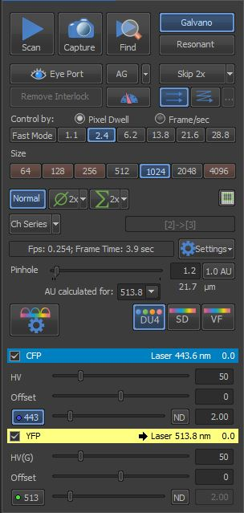

-Right click on the image and select “**Ratio View**”.

-Right click on the image to select and set “**Ratio Properties**”. Set the Acceptor channel to the **Numerator** and Donor channel to the **Denominator**. Select **Apply**.

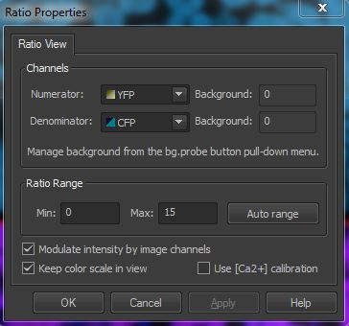

1. **Acceptor Photobleaching: Provides a single FRET measurement.**

This method is simple and accurate, but provides only a single time point.

This method cannot be used for FRET measurements over time or for specimens or organelles that are moving.

-Select desired Optical Configuration for the Donor/Acceptor combination.

-Select **Scan** and optimize the **HV/Offset** for both the Donor and Acceptor images.

-Right click on the desktop, select **Acquisition Settings/A1PlusStimulation**.

Select photobleaching laser (Acceptor laser)

Set laser intensity (100%)

Select Synchronize Lasers

-Right click on the desktop, select **Acquisition Settings/ND Stimulation**.

Select Phase #1, AcqStim=Acquisition, no ROI, Loop 1-3

Select Phase #2, AcqStim=Bleaching, ROI=S1, Duration msec-sec, Loop=1

Select Phase #3, AcqStim=Acquisition, no ROI, Loop 1-3

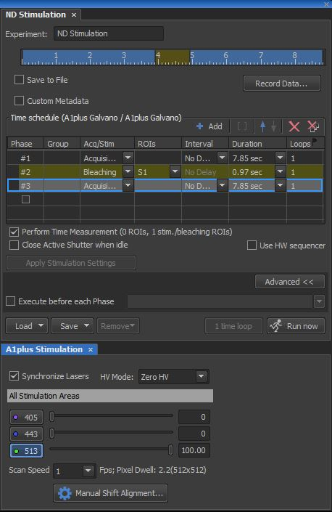

-Set Bleaching ROI.

Select ROI icon from right side of image. Select desired shape and draw ROI on the image.

Right click on the ROI and select **Use as Stimulation ROI:S1**.

ROI on the image should display S1:1.

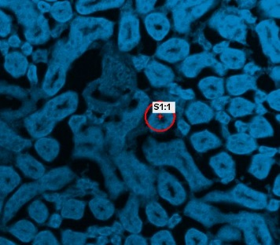

-From **ND Stimulation** window, select **Apply Stimulation Settings**. If the Apply Stimulation Settings button is not available, be sure that the ROI is set to S1 (stimulation ROI) and that the Synchronize Lasers option has been selected within A1plus Stimulation window.

-From the **ND Stimulation** window, select **Run now** to perform/acquire the stimulation image series. If the Run now button is not available, be sure that the Apply Stimulation Settings button has been selected.

1. **Corrected Ratio**

-You will need a Donor-only sample, Acceptor-only sample and FRET sample.

-Select desired Optical Configuration for the Donor/Acceptor combination.

-From Settings, select exem: 1Ex2Em2

-Set: Em1 to the Donor PMT channel

Em2 to the Acceptor PMT channel

Ex1 to the Donor laser excitation

Ex2 to the Acceptor laser excitation

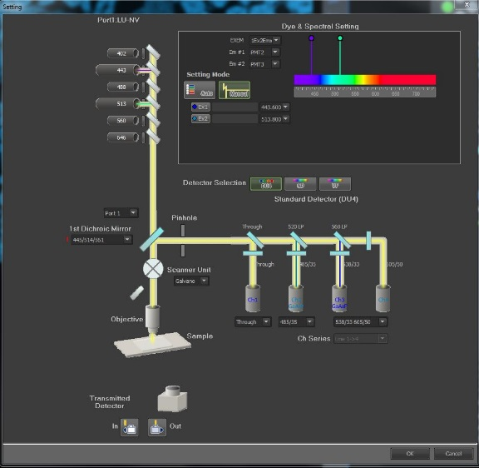 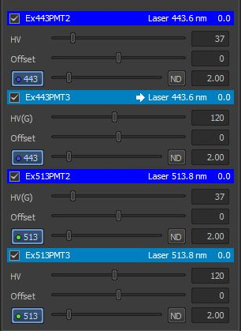

-Select “Ok” and four PMT settings should appear:

Dd = Donor excitation laser and Donor emission detection channel (PMT)

Da = Donor excitation laser and Acceptor emission detection channel

Ad = Acceptor excitation laser and Donor emission detection channel

Aa = Acceptor excitation laser and Acceptor emission detection channel

You will record these four images for the Donor-only sample, the Acceptor-only sample and the FRET sample (so 12 images total).

-From the HELP menu, search for “FRET METHOD “and select “Capturing FRET Image/FRET Calibration”. Scroll down to FRET Method for a description of the corrected ratio calculations. There are two options: Sensitized Emission and Specified Bleed Through. Also, from the HELP menu, search for “FRET Example” for a step-by-step instruction of the corrected ratio method.

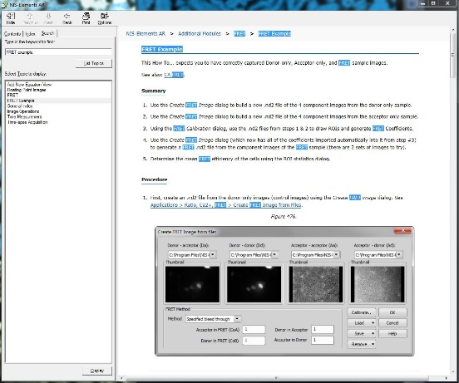 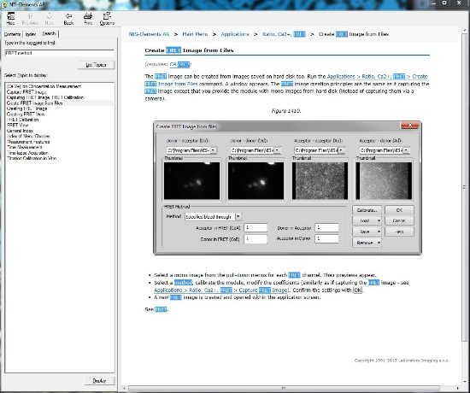

Essentially the following steps are required for Corrected FRET:

1. Put the FRET sample on the microscope and optimize the settings for each of the four images.
2. Remove the FRET sample and place the Donor-only sample on the microscope. Without changing the image settings, collect the four images (Dd, Da, Ad, Aa) for the Donor-only sample. Save each image as a **separate** image file.
3. Select **Applications/Create FRET Image from Files**. Enter each of the four donor-only image files into the menu. Set all of the coefficient parameters to **1**. Set FRET Method to **Donor-Only Sample**. Select “**Ok**” to generate a Donor-only image. **Save** Donor-only image.
4. Repeat Steps b-c for the Acceptor-only slide, setting the FRET Method to **Acceptor-Only Sample**.

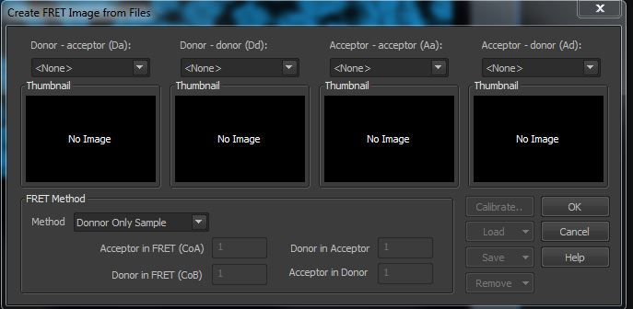

1. Select **Applications/FRET Calibration**, enter the Donor-only and Acceptor-only files. For each image, draw a ROI for the positive signal and a ROI for the background. Select “**OK**” and the menu for “**Default FRET Coefficients**” should appear.

Select **Method** – either Sensitize Emission or Specific Bleedthrough.

Select OK

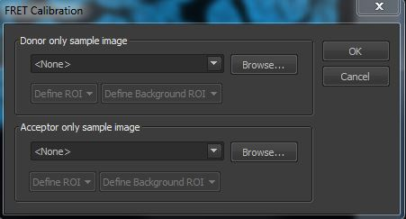

1. Select **Applications/Create FRET Image from Files**. Notice that the coefficient parameters have now been calculated and automatically entered. There will be two parameters for the Sensitized Emission method and four parameters for the Specified Bleed Through method. Enter each of the FRET image files into the menu and select “**Ok**” to generate the final FRET image.
2. The final FRET image file will have each of the four original images plus a Corrected FRET Image and a FRET Efficiency image.
3. Once these values have been calculated, right click on the image window and select **FRET View** to have the Corrected FRET and FRET Efficiency images displayed during acquisition.

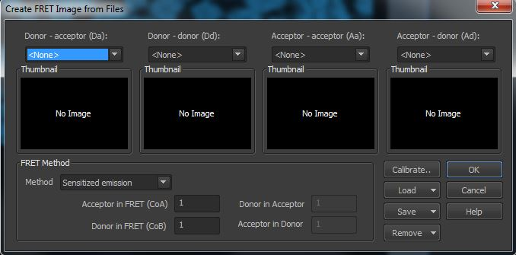

**Photobleaching (FRAP) and Photoactivation on the Nikon A1 Confocal**

-Select desired Optical Configuration.

-Select **Scan** and optimize the **HV/Offset** for the selected detection channels.

-Right click on the desktop, select **Acquisition Settings/A1PlusStimulation**.

Select photobleaching/photoactivation laser

Set laser intensity (100%)

Select Synchronize Lasers

-Right click on the desktop, select **Acquisition Settings/ND Stimulation**.

Select Phase #1, AcqStim=Acquisition, no ROI, Loop 1-3

Select Phase #2, AcqStim=Bleaching, ROI=S1, Duration msec-sec, Loop=1

Select Phase #3, AcqStim=Acquisition, no ROI, Loop 1-3



To group Phases together, hold the shift-key down and click on each Phase to be grouped. Next, select the [] icon (next to the Add button). A bracket should appear in the Group column. Indicate the number of times the Group should be repeated (1X, 2X, etc).

-Set Bleaching ROI.

Select ROI icon from right side of image. Select desired shape and draw ROI on the image.

Right click on the ROI and select **Use as Stimulation ROI:S1**.

ROI on the image should display S1:1.



-From **ND Stimulation** window, select **Apply Stimulation Settings**. If the Apply Stimulation Settings button is not available, be sure that the ROI is set to S1 (stimulation ROI) and that the Synchronize Lasers option has been selected within A1plus Stimulation window.

-From the **ND Stimulation** window, select **Run now** to perform/acquire the stimulation image series. If the Run now button is not available, be sure that the Apply Stimulation Settings button has been selected.