**Nikon TIRF System Instructions**

**June 2015**

**Caution!!**

**\*STORM/TIRF Lasers are very intense. Use caution when working with these lasers.**

**\*Never look down the barrel of the objective where the laser exits the objective lens.**

**\*Always wear Laser Safety Goggles during Laser Alignment.**

**\*Always use the TIRF stage which includes Laser Safety Interlocks.**

**Instrument Set-up:**

1. Turn all components of the Nikon A1 hardware “ON”.
2. Attach the TIRF stage on top of the standard stage insert.
3. Select the 100x (NA 1.49) TIRF lens. Clean the objective well.
4. Make sure the objective lens is close to the correct focus position and not “escaped.”
5. Make sure the correction collar is set to the correct position (0.17 for #1.5 coverslip).
6. Remove DIC Prism from beneath objective lens (100X 1.49NA).
7. Remove the STORM lens (**A**) (pull up), and confirm that the ¼ waveplate is inserted.
8. Remove the 3D STORM lens that is located to the left of the camera. Pull lens toward you to remove the lens.

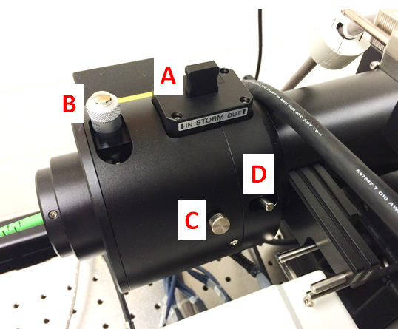

**Focus on the Specimen:**

1. Open Elements with the **“Andor”** driver.

If you receive a “Driver Error”, be sure that the ANDOR camera is turned on. The “ON” button is a flat, silver button located at the middle, back of the camera.

1. It would be helpful to have the following Elements Windows open and available:

TiPad

DU-897 Settings

TIRF/SR-active Window

AVI Movie

ND Acquisition

LUT

1. Place the specimen on the stage and cover stage with the TIRF Stage coverplate. A laser interlock will engage when the coverplate is removed, so the plate must be in place for the laser shutter to open.
2. Focus on the sample by eye (eg, EpiTxRed) or by using the Perfect Focus System (PFS).

For PFS, add a drop of oil to the 100x objective lens. Focus down (away) slightly (50-100um).

Place specimen on the stage and select PFS. The PFS button will blink until the coverslip focus is located.

Using Fine Focus, focus up until the PFS button stops blinking (constant green). The Fine Focus button will no longer control the Z-focus. At this point, use the PFS Focus knob to control the specimen focus.

1. For thick tissues, you may need to move the stage position off of the tissue section itself to a clear portion of the coverslip once the tissue has been focused.

**Coarse Alignment of TIRF:**

1. Select the **TIRF___UP** optical alignment configuration from top toolbar. The alignment will be specific for the laser being used (eg, TIRF488UP).
2. Turn the laser light “ON” by clicking on the **AOTF** icon located at the bottom of the **TIRF/SR-active** window.
3. Adjust top knob on TIRF arm (**B**) to center laser above microscope, if necessary.

Remember to wear Laser Safety Googles!

1. Unlock set screw (**C**) and focus the beam with slider (**D**) until the beam is as tight as possible.
2. Turn the laser “OFF” by clicking on the **AOTF** icon at the bottom of the **TIRF/SR-active** window.

**Fine Alignment of the TIRF Angle:**

1. Select the **TIRF___** optical configuration. Again, this option will be specific for the laser being used (eg, TIRF488).
2. In the **DU-897 Settings** window, select:

**No Binning**

**1 frame exposure time**

**EM Gain 17MHz at 16 bit**

**EM gain ~300**

1. Select **“Play”** icon to turn the camera on for imaging. This will also automatically open the laser shutter. Alternatively, you can also open/close the laser shutter by clicking the **AOTF** icon located at the bottom of the **TIRF/SR-active** window.
2. If you do not see an image, be sure that the microscope light path is set for the camera (R100). Increase laser power until a fluorescence image is detected.
3. Focus down through the sample until the image disappears, then focus up until the sample just comes back into focus. This focal plane should be at/near the coverslip, which is necessary for TIRF.
4. Use **Ti Pad** to fine tune the TIRF angle in Live Mode until signal to noise is optimum.
   1. The initial angle of the laser beam should be positioned near the critical angle (approximately 4,000).
   2. To fine tune the TIRF angle, click on the icon to the right of the “Extra Fine” option to control the TIRF angle by the mouse roller ball.

Remember that the TIRF angle may be adjusted in a Coarse (100), Fine (5) and Extra Fine (0.1) increments.

* 1. As you increase the TIRF angle, the image should become very bright. A further increase in the TIRF angle will significantly reduce the image intensity. At this point you will be in TIRF mode. As you continue to increase the TIRF angle, the illumination angle will become more oblique and the imaging thickness very thin.

1. Once the TIRF angle is set, select **“Stop”** icon to turn the camera and laser off.

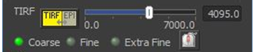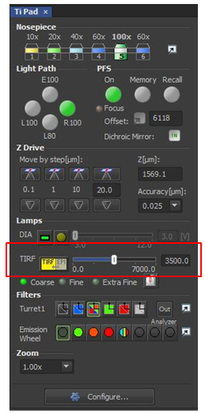

**AVI Movie File Acquisition:**

1. To record a real-time movie of the TIRF images, select **“Play”** icon to turn the camera and laser on for imaging. If you do not see an image, be sure that the microscope light path is set for the camera (R100). Increase laser power until a fluorescence image is detected.
2. From the **AVI Acquisition** window, enter the directory and filename for the time series recording.
3. Press the **Record** button to begin imaging.
4. At the desired time, select the **Stop** button to end the image recording. The AVI movie file will automatically be saved to the selected directory.
5. Once the recording has ended, select **“Stop”** icon to turn the camera and laser off.

**Z-Series Acquisition:**

1. To record an XYZ image series using the TIRF laser and the Andor camera, select **“Play”** icon to turn the camera and laser on for imaging. If you do not see an image, be sure that the microscope light path is set for the camera (R100). Increase laser power until a fluorescence image is detected.
2. From the **ND Acquisition** window, set the top and bottom boundaries and the Z-Step for the XYZ series.
3. Select **“Run Now”** to begin imaging.
4. Once the recording has ended, save the image series to the appropriate drive.

**Instrument Clean-Up:**

1. Save all data and Exit out of the Elements software.
2. Remove specimen from the microscope stage and carefully clean the 100x oil objective.
3. Return the microscope to the 10x objective setting.
4. Remove the TIRF stage.
5. Shut down the Nikon A1 hardware.
6. Indicate “TIRF” in the comment section of the log book.